**3.5 SSS, SAS, ASA and AAS Practice**

*Recap of Top 4 Triangle Congruence Postulates*

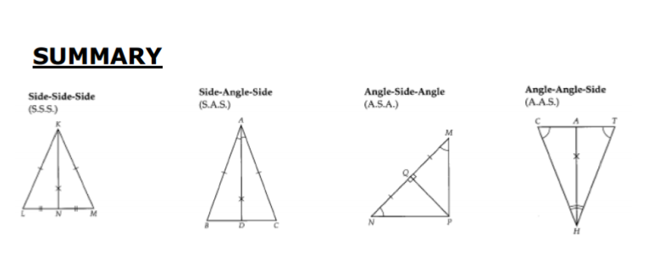

**Part 1:**

*State if the two triangles are congruent. If they are, state how you know (SSS, SAS, ASA, or AAS)*

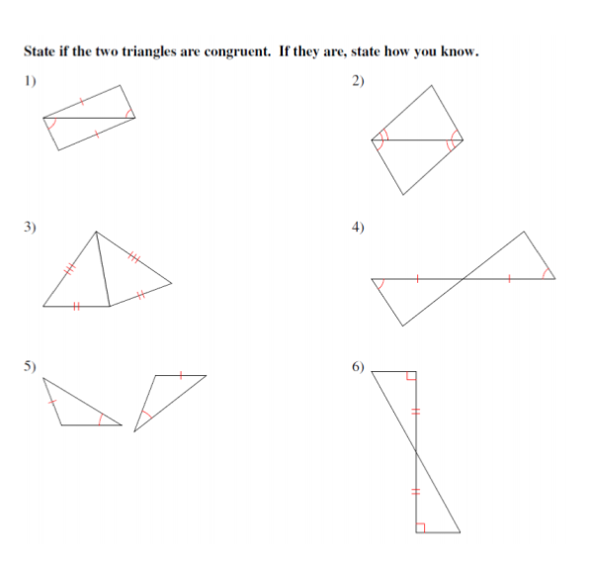

Part 2:

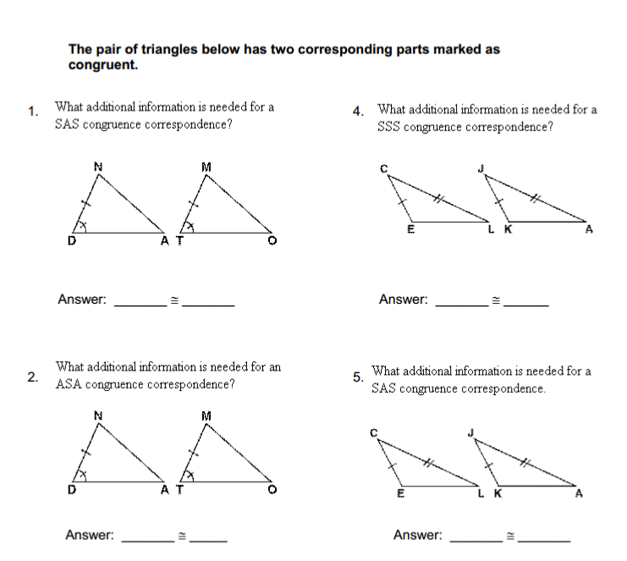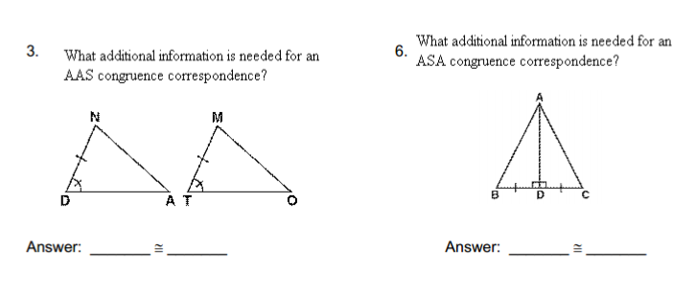

Part 3:

1. Mark up the triangles with the given information
2. State if you can prove the triangles congruent
3. State how you know they are congruent (SSS, SAS, AAS, or ASA)

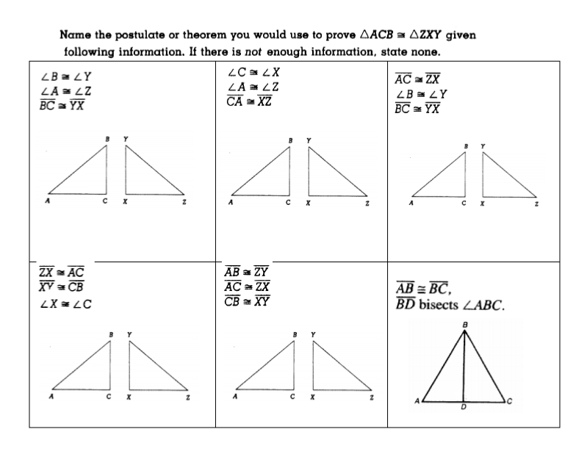 

Part 3:

